Social Media

**Introduction:**

**Social media** refers to websites and applications that are designed to allow people to share content quickly, efficiently, and in real-time. While many people access social media through smartphone apps, this communication tool started with computers, and social media can refer to any internet communication tool that allows users to broadly share content and engage with the public. Such as Facebook, Twitter etc.

**Objective:**

**Our objective is to make communication easier for everyone. To allow users to share ideas, digital photos and videos, posts, and to inform others about online or real-world activities and events with people in their network.** While in-person social networking – such as gathering in a village market to talk about events – has existed since the earliest development of towns. The web enables people to connect with others who live in different locations, ranging from across a city to across the world. Depending on the social media platform, members may be able to contact any other member. In other cases, members can contact anyone they have a connection to, and subsequently anyone that contact has a connection to, and so on.

**Target Customer:**

Social media users. From young people to middle aged people assuming the old(above 60year) people are not interested in using social media or they are not familiar with the technology of the present time.

**Feature:**

* Create/Share posts.
* Add/Remove friends
* Create/Share contents.
* Notifications.
* Sharing pictures/videos.
* See what friends posted/shared.
* React on friends posts.

**Tools:**

HTML/CSS

MySQL

PHP

WEB SERVER

**Challenge:**

The site should be user friendly, otherwise people won’t be interested in using it. For example, if people cannot sign up, they won’t use it ever. So, the main target is to maintain the relation between our backend and frontend work, to maintain the connection among them. So when many people are using it they don’t face any errors and they can use it properly. We’ll need to keep the flexibility and security issues in our mind. So that no one’s information gets leaked and people can keep their contents safe.

**ER Diagram:** 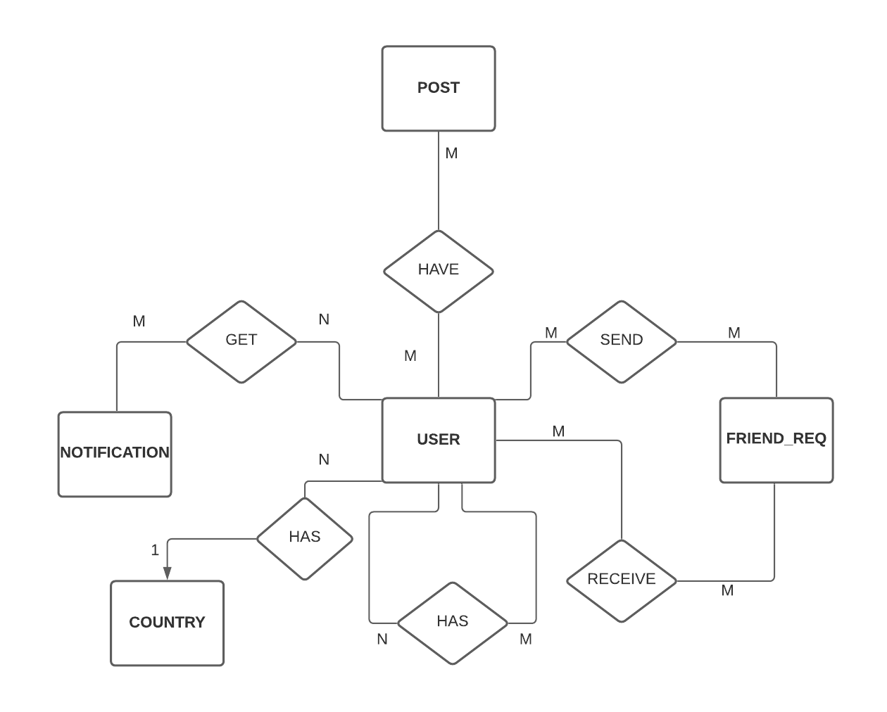

**Schema Diagram:** 